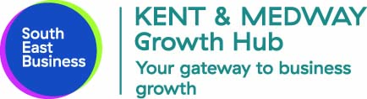
LIVE CHAT SERVICE
You can embed the code below on your chosen website page to provide a free Live Chat service. All we need to know is the web address of the page you are using.

<!-- Start of LiveChat (www.livechatinc.com) code -->
<script type="text/javascript">
window.__lc = window.__lc || {};
window.__lc.license = 2445091;
(function() {
var lc = document.createElement('script'); lc.type = 'text/javascript'; lc.async = true;
lc.src = ('https:' == document.location.protocol ? 'https://' : 'http://') + 'cdn.livechatinc.com/tracking.js';
var s = document.getElementsByTagName('script')[0]; s.parentNode.insertBefore(lc, s);
})();
</script>
<!-- End of LiveChat code -->

SAMPLE TEXT FOR YOUR PAGE
Businesses in Kent can now access online business advice through a FREE Live Chat in one click. Expert business advice is provided by Kent and Medway Growth Hub, providing easy access to support for businesses to start-up and grow. This new online business advice service is delivered in partnership with MiVentures.

How Live Chat benefits local businesses:
- Easy to use - direct access to professional business advisors
- It’s instant - it will save businesses time and money, no need to travel
- Digital toolkit - download fact sheets, plans, business templates
- Local connectivity - connect and network with other local businesses
- Be connected - join key business groups in your industry and local network
- Personalised – create your own profile to promote your business

This Live Chat service is available Monday – Friday between 9am and 7pm (excluding public bank holidays).

The Live Chat service is part of Kent and Medway Growth Hub “Ask Phil' marketing campaign. The “Ask Phil” campaign will run for the next 18 months across multiple channels

